Protect All Lines. Protect All Lives.™

50 patients die each day in US hospitals due to bloodstream infections.^{1,2}
Catheter-related bloodstream infections are preventable, often fatal and can significantly impact hospital CMS reimbursement.
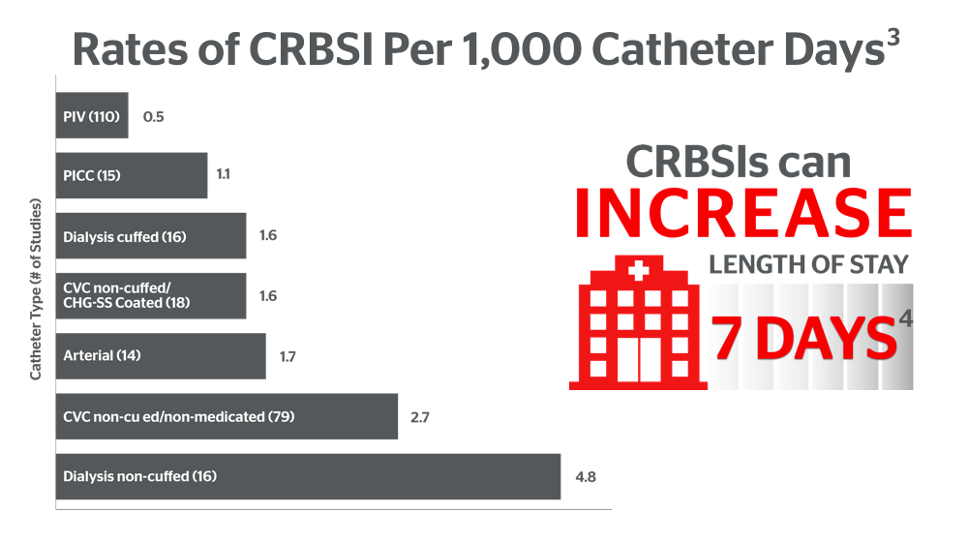

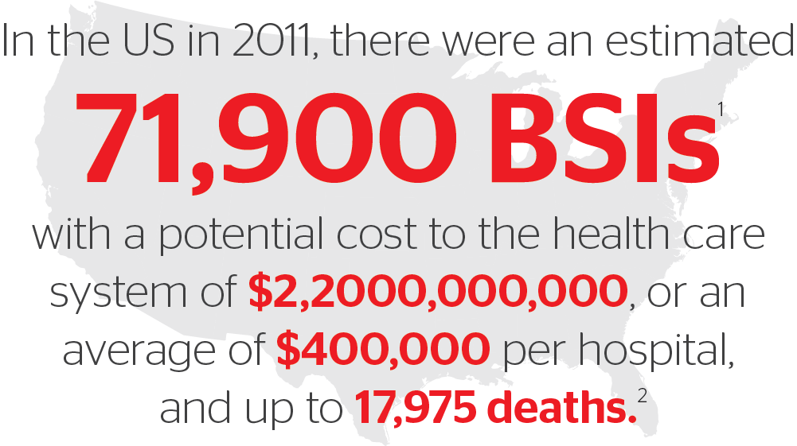

Peripheral IVs are the most frequently used invasive device in hospitals,⁷ and standards of care now recommend clinically indicated replacement. This change can lead to improved outcomes, increased efficiency, and better patient experience. "There is no risk-free line, and vigilance is required with any vascular device placement.”⁸
