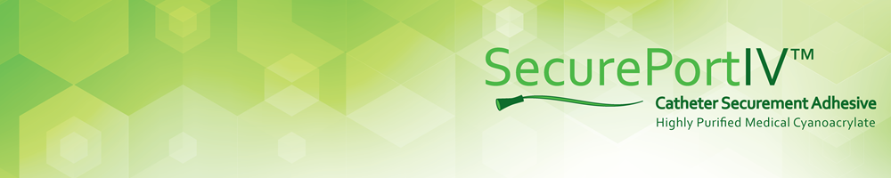

SecurePortIV™

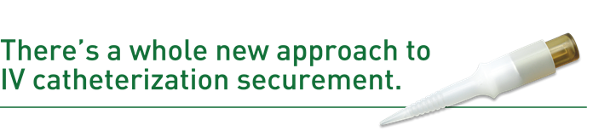
Peripheral IV catheter insertion is the most common invasive hospital procedure performed worldwide. The problem? It’s extremely prone to complications, with an overall failure rate of 35 to 50 percent – even in the hands of the most experienced caregivers.

But with SecurePortIV, all that is changing.
- 3X stronger securement than transparent film dressings alone and superior adhesiveness compared with mechanical securement devices¹
- Effectively seals the catheter insertion site
  - Can help reduce early dressing changes and eliminate 24-48 hour initial dressing change protocols
- Immobilizes skin flora that can't be removed by standard skin prep and establishes a microbial barrier against new pathogens
¹ Data on file, Adhezion Biomedical, LLC.

