Evone and Tritube for tracheal surgery
In a patient with a length of 1.71 meter, a weight of 120 kg and a BMI of 41 Evone and Tritube were successfully used for tracheal surgery. For safety reasons inspiratory oxygen concentration was set to and kept at 21%. After 85 minutes, at identical settings of Evone, measured ventilation parameters as well as pulse oximetry saturation have not changed indicating lung mechanics and aeration of the lungs were not affected.

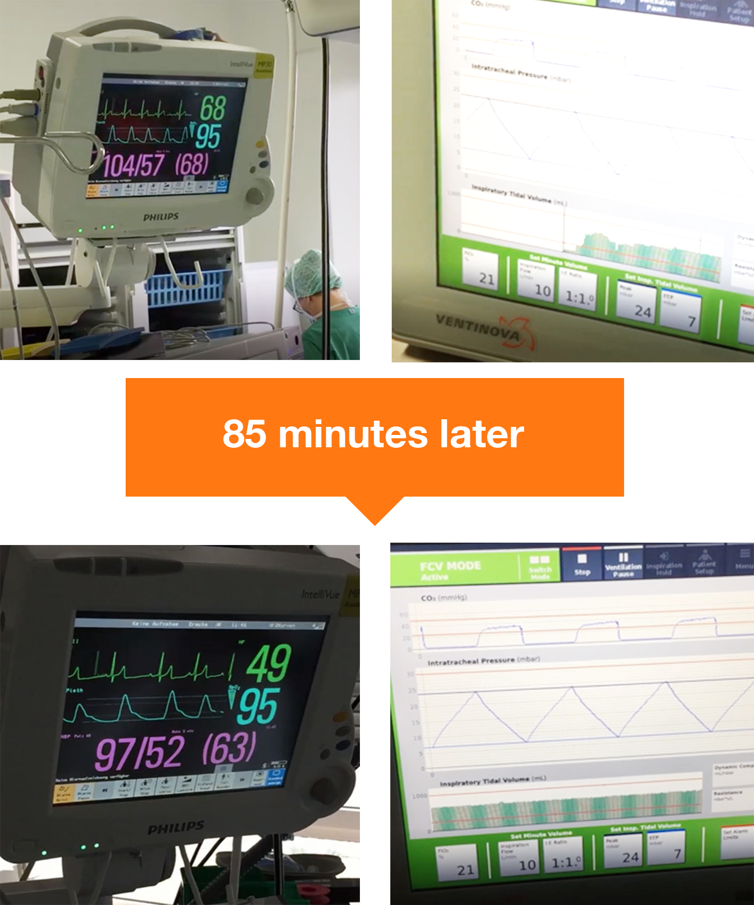

K. Jeyarajah and I. Ahmad. Awake tracheal placement of the Tritube® under flexible bronchoscopic guidance. Anaesthesia Cases / 2018-0097 / ISSN 2396-8397 epub Jul 2018
Dr Imran Ahmad is the first to describe a challenging airway case, in which Tritube and Evone were found of significant value. The patient, scheduled for panendoscopy, had an anticipated difficult airway combined with airway pathology and COPD. Dr Ahmad therefore opted for awake tracheal intubation with Tritube. After awake placement of the flexible bronchoscope, Tritube was elegantly guided using a silk surture tied over the bronchoscope. The patient was anesthetized and adequately ventilated with Evone for 45 minutes. Tritube allowed adequate surgical access with the advantage of a definitive airway, whilst continuous

